Name of Your Product

Your final paper should consist of a 3- to 4-page summary of your project, followed by several appendices.

Your summary should tell the story of your design, including:

- Your opportunity statement

- How your design meets user needs
  - Include 3D assembly model(s) of your final design and photo(s) of your final product
  - Include individual component / subassembly drawing(s) / photo(s) as needed to communicate design details
  - Do not include fully dimensioned orthographic drawings in your summary
  - The example below provides excellent visuals, but should include more labels and annotations of key features and functions

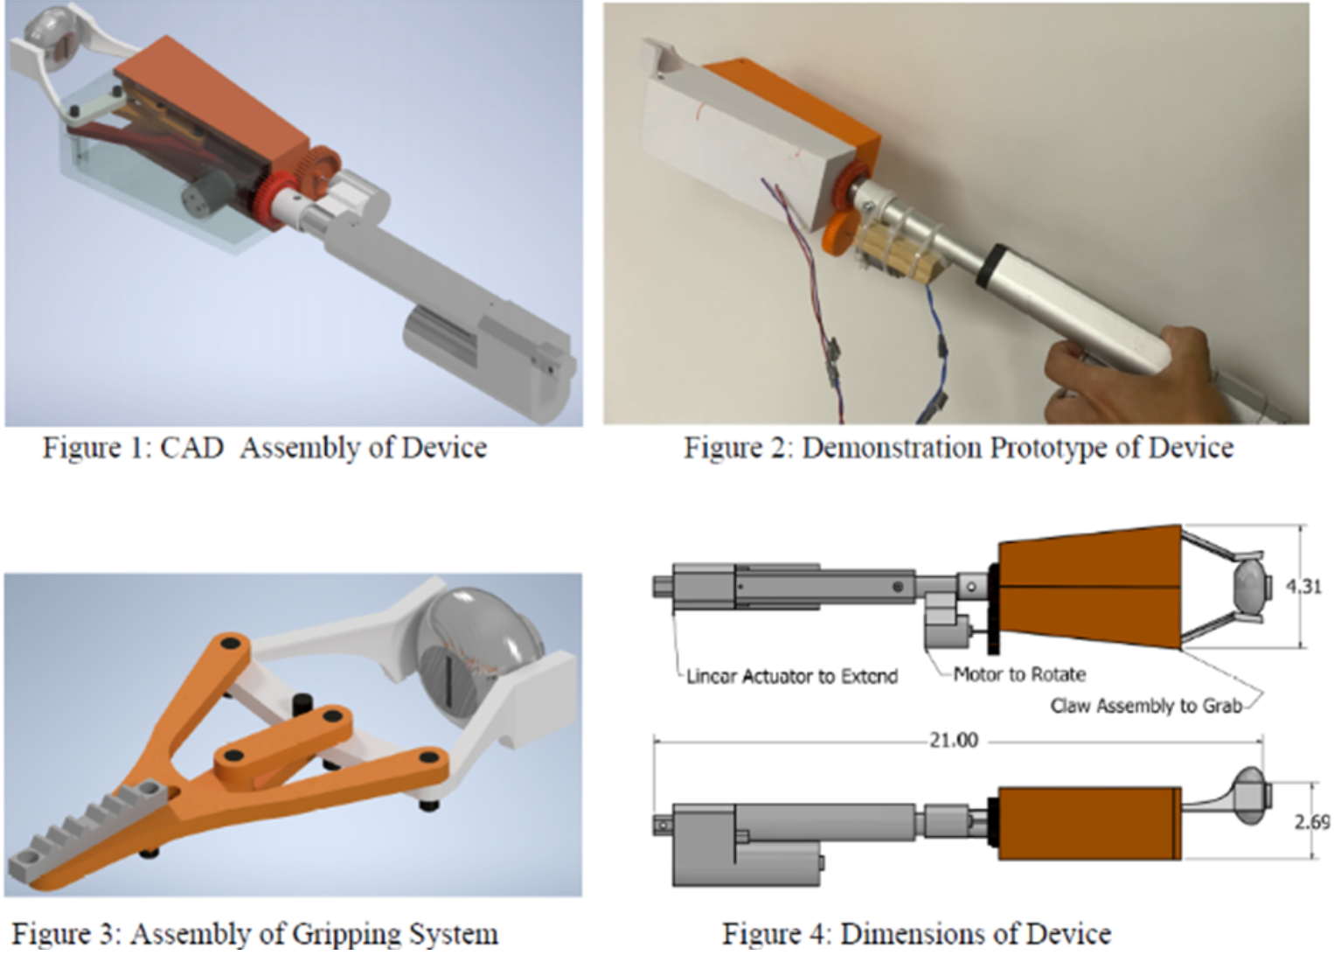
- Next steps - describe specific design updates you would make if you were provided more time and resources for this project, and if your product was mass produced
  - Identify the specific type of material you would use for each component and, importantly, why you have chosen each material type
    - Consider our LCA unit and the environmental impact of various material types
  - Select three strategies from the Ecodesign Strategy Wheel that you would employ to improve your product
    - What are the repercussions of each strategy (benefits and consequences)?

- Summarize the broader impacts of your design
  - Explicitly identify how you have considered the benefits and risks / trade-offs in each of these categories:
    - Public health, safety, and welfare
    - Global and/or cultural factors
    - Triple Bottom Line: social, environmental, and economic factors
  - When compiling your broader impacts, think about…
    - People: safety hazards you avoided / considered, ergonomics, user-friendliness, learnability, direct / indirect quality-of-life improvements
    - Planet: material consumption / reduction, weight and/or volume reduction for transport, use of local materials, end-of-life disposal (biodegradability / recyclability / reusability), resilience, repairability, embodied energy (i.e., CO2eq)
    - Profit: unique differentiation, ease of manufacturing / assembly, use of local labor
  - Note: these considerations can include any future improvements you would make
  - Suggested format = list / table (not a paragraph)

Appendix 1: Problem Framing (Start each appendix on a new page)
Summarize your key problem framing items in list / table form
- Stakeholders: identify how each stakeholder influenced specific design features
- Research: identify how each piece of research influenced specific design features, include citations → [#]
- Assumptions: use the framework → Due to some information, assumption. Therefore design decision (if you don’t have any knowledge gaps, you may not need any assumptions)
- Design Specifications: constraints and evaluation metrics, include benchmarks / objectives, measured quantities, and justifications as appropriate
  - It should be clear how each design spec influenced specific design features
  - Identify how your product performed relative to each design spec

Appendix 2: Test Results
- Complete test plan
- Design decision(s) made due to this test

Appendix 3: Design Details
- Any additional photos of your demonstration prototype that you feel are necessary to fully communicate your design, appropriately labeled and annotated
- All final CAD drawings - requirements are identical to DR2, including:
  - Each CAD drawing should be a full page PDF with title block
  - Wiring diagrams, if applicable
  - Cura screenshots, if applicable

Appendix 4: Budget Tracker
Include any expenses that will be covered by the college (filament and reimbursements).

Appendix 5: Gantt Chart
Include a legible Gantt chart. You may need to orient it in landscape view so it fits on one page, or split it across two pages.

Appendix 6: AI Disclosure
Identify if / how AI was used in your project.

Appendix 7: Miscellaneous (if necessary)
Include any other information / images / documents that support your design. If an Arduino is used, include the code for it in this appendix. Delete this appendix if nothing else is included.

References
Use IEEE formatting like we have been all year.

Individual Contributions
In a table below, list your project contributions since DR3. Enter your own information only!

Table XX: Individual contributions
Name | Contributions | Hours since DR3
- Task A
- Task B
- ...
- Task A
- Task B
- ...
- Task A
- Task B
- ...
- Task A
- Task B
- ...
- Task A
- Task B
- ...

Submission
Delete instructions (blue text) and submit your paper as a PDF via Canvas. Be sure to review the grading rubric!

Follow all technical writing guidelines discussed in class, including captioning figures (below) and tables (above), referring to your figures and tables in the body of your text beforehand (e.g., as seen in Figure 1 below…), providing in-text citations as necessary, labeling and annotating images, and writing clearly and concisely.

Identify primary use cases
-foucs on other use cases
non english speakers
inconsistent capitalizations

